Andrew Wells

CPE301 – SPRING 2016

Design Assignment 5

**DO NOT REMOVE THIS PAGE DURING SUBMISSION:**

The student understands that all required components should be submitted in complete for grading of this assignment.

|  |  |  |  |
| --- | --- | --- | --- |
| **NO** | **SUBMISSION ITEM** | **COMPLETED (Y/N)** | **MARKS**  **(/MAX)** |
| 0. | COMPONENTS LIST AND CONNECTION BLOCK DIAGRAM w/ PINS |  |  |
| 1. | INITIAL CODE OF TASK 1/A |  |  |
| 2. | INCREMENTAL / DIFFERENTIAL CODE OF TASK 2/B |  |  |
| 3. | INCREMENTAL / DIFFERENTIAL CODE OF TASK 3/C |  |  |
| 4. | INCREMENTAL / DIFFERENTIAL CODE OF TASK 4/D |  |  |
| 5. | INCREMENTAL / DIFFERENTIAL CODE OF TASK 5/E |  |  |
| 6. | SCHEMATICS |  |  |
| 7. | SCREENSHOTS OF EACH TASK OUTPUT |  |  |
| 8. | SCREENSHOT OF EACH DEMO |  |  |
| 9. | VIDEO LINKS OF EACH DEMO |  |  |
| 10. | GOOGLECODE LINK OF THE DA |  |  |
|  |  |  |  |
|  |  |  |  |

|  |  |  |  |
| --- | --- | --- | --- |
| 0. | COMPONENTS LIST AND CONNECTION BLOCK DIAGRAM w/ PINS |  |  |

Xplained Mini: Atmega328P Micro Controller

Servo Motor

Stepper Motor

DC Motor

TIP120 Transistor

ILD74 Opto-isolator

ULN3002A

Potentiometer

|  |  |  |  |
| --- | --- | --- | --- |
| 1. | INITIAL CODE OF TASK 1 |  |  |

#define *F_CPU* 8000000UL // Set clock to 8Mhz

#include <avr/io.h>

#include <stdio.h>

#include <util/delay.h>

#define ENABLE 6

void ADCstart(); // Function to initialize the ADC

void read_adc(); // Function to read from the ADC

void DUTY_DELAY(int DELAY);// Function to allow variable delay

volatile float ADCvalue; // Variable to save the voltage value

int main(void)

{

int On_Time;// variable for the On part of the duty cycle

int OFF_Time;// variable for the Off part of the duty cycle

DDRD |= (1<<6); // Turn on PORTD.6

PORTD = (1<<ENABLE); // Power signal to the DC motor

ADCstart(); // initialize the ADC port

while (1)

{

ADCvalue = 0; // reset potentiometer value

ADCSRA |= (1<<ADSC);// write one to ADSC bit to start conversion

while(ADCSRA & (1<<ADSC))// wait until conversion is complete

{

}

ADCvalue = ADC;// save voltage

ADCvalue = (ADCvalue*5.0)/1024; // Calculate Vin

ADCvalue = ((ADCvalue/5.0)*100); // Calculate what percent of maximum voltage is received

OFF_Time = 100 - (int)ADCvalue; // Calculate Off part of duty cycle

On_Time = 100 - OFF_Time; // Calculate On part of duty cycle

PORTD = PORTD | (1<<ENABLE); // Motor off

DUTY_DELAY(OFF_Time-1);// How long the motor is off

PORTD = PORTD & (~(1<<ENABLE)); // Motor on

DUTY_DELAY(On_Time-1);// How long the motor is on

}

return 0;

}

void DUTY_DELAY(int DELAY)

{// function to allow variable delays

while(DELAY--)

{

*_delay_ms*(1);

}

}

void ADCstart()

{

ADMUX = (0<<REFS1)| // Reference Selection Bits

(1<<REFS0)| //use AVcc as reference

(0<<ADLAR)| //ADC Left adjust Result

(0<<MUX2)| // Analog Channel Selection Bits

(1<<MUX1)| // ADC2 (PC2, PIN25)

(0<<MUX0);

ADCSRA = (1<<ADEN)| //ADC Enable

(0<<ADSC)| //ADC Start Conversion

(0<<ADIF)| //ADC Auto Trigger Enable

(0<<ADIE)| //ADC Interrupt Flag

(0<<ADATE)| //ADC Interrupt Enable

(1<<ADPS2)| //ADC Prescaler Bits

(0<<ADPS1)|

(1<<ADPS0);

return;

}

void read_adc() // function to read the value from the potentiometer

{

ADCSRA |= (1<<ADSC);// write one to ADSC bit to start conversion

while(ADCSRA & (1<<ADSC))// wait until conversion is complete

{

}

ADCvalue = ADC;// save voltage

return;

}

**FLOWCHART TASK 1:**

FALSE

Enable PB6 as output and set to high

Initialize ADC

ADCvalue = 0

Start ADC Conversion

Conversion Complete?

TRUE

ADCvalue = ADC

Calculate Delay

PORTD = PORTD | (1<<PB6)

START

DELAY

PORTD = PORTD | ~(1<<PB6)

DELAY

|  |  |  |  |
| --- | --- | --- | --- |
| 2. | INCREMENTAL / DIFFERENTIAL CODE OF TASK 2 |  |  |

#define *F_CPU* 8000000UL // Set clock to 8Mhz, Ignored by Xplained Mini Board

#include <avr/io.h>

#include <util/delay.h>

void ADCstart(); // Function to initialize the ADC

void DUTY_DELAY(int DELAY); // function to allow variable delay

volatile float ADCvalue; // Variable to save the voltage value

int main()

{

int OFF_Time; // variable for cycle Off time

// Black = PD0

// Red = PD1

// Green = PD2

// Blue = PD3

DDRD = 0xFF; // set PORTD as output

ADCstart(); // initialize the ADC port

while(1)

{

ADCvalue = 0;

ADCSRA |= (1<<ADSC);// write one to ADSC bit to start conversion

while(ADCSRA & (1<<ADSC))// wait until conversion is complete

{

}

ADCvalue = ADC;// save voltage

ADCvalue = (ADCvalue*5.0)/1024;

ADCvalue = ((ADCvalue/5.0)*100); // Calculate what percent of maximum voltage is recieved

OFF_Time = 100 - ADCvalue; // Calculate off time

PORTD = 0X66;// Cycle for magnets

DUTY_DELAY(OFF_Time+1);// how long to wait to change magnets

PORTD = 0xCC;// Cycle for magnets

DUTY_DELAY(OFF_Time+1);// how long to wait to change magnets

PORTD = 0x99;// Cycle for magnets

DUTY_DELAY(OFF_Time+1);// how long to wait to change magnets

PORTD = 0x33;// Cycle for magnets

DUTY_DELAY(OFF_Time+1);// how long ot wait to change magnets

}

return 0;

}

void DUTY_DELAY(int DELAY)

{// Function to allow variable delay

while(DELAY--)

{

*_delay_ms*(1);

}

}

void ADCstart()

{

ADMUX = (0<<REFS1)| // Reference Selection Bits

(1<<REFS0)| //use AVcc as reference

(0<<ADLAR)| //ADC Left adjust Result

(0<<MUX2)| // Analog Channel Selection Bits

(1<<MUX1)| // ADC2 (PC2, PIN25)

(0<<MUX0);

ADCSRA = (1<<ADEN)| //ADC Enable

(0<<ADSC)| //ADC Start Conversion

(0<<ADIF)| //ADC Auto Trigger Enable

(0<<ADIE)| //ADC Interrupt Flag

(0<<ADATE)| //ADC Interrupt Enable

(1<<ADPS2)| //ADC Prescaler Bits

(0<<ADPS1)|

(1<<ADPS0);

return;

}

**FLOWCHART TASK 2:**

START

DDRD=0xFF

Initialize ADC PORT

ADCvalue = 0

Start ADC Conversion

FALSE

Conversion Complete?

TRUE

ADCvalue = ADC

Calculate Delay

PORTD = 0x66

DELAY

PORTD = 0xCC

DELAY

PORTD = 0x66

PORTD = 0x66

DELAY

DELAY

|  |  |  |  |
| --- | --- | --- | --- |
| 3. | INCREMENTAL / DIFFERENTIAL CODE OF TASK 3 |  |  |

#define *F_CPU* 8000000UL // Set clock to 8Mhz, ignored by Xplained Mini board

#include <avr/io.h>

#include <util/delay.h>

void ADCstart(); // Function to initialize the ADC

void TIMER1_INIT(); // Function to initialize Timer 1

volatile float ADCvalue; // Variable to save the voltage value

int main()

{

int ANGLE;

ADCstart(); // initialize the ADC port

DDRB = (1<< PORTB1); // Set PORTB1 pin as output

ICR1 = 40000;// 50Hz PWN at 16Mhz, TOP = ICR1

OCR1A = 1000;// 1000 = 0 degrees, 4600 = 180 degrees

TIMER1_INIT();

//Brown = Ground

// Red = Power

// Orange = Signal

while(1)

{

ADCvalue = 0;

ADCSRA |= (1<<ADSC);// write one to ADSC bit to start conversion

while(ADCSRA & (1<<ADSC))// wait until conversion is complete

{

}

ADCvalue = ADC;// save voltage

ADCvalue = (ADCvalue*5.0)/1024;// Calculate Vin

ADCvalue = ((ADCvalue/5.0)*3600); // Calculate how far the angle is above 0 degrees

ANGLE = ADCvalue + 1000; // Add value for 0 degree

OCR1A = ANGLE; // Save value for PWN duty cycle

}

return 0;

}

void ADCstart()

{

ADMUX = (0<<REFS1)| // Reference Selection Bits

(1<<REFS0)| //use AVcc as reference

(0<<ADLAR)| //ADC Left adjust Result

(0<<MUX2)| // Analog Channel Selection Bits

(1<<MUX1)| // ADC2 (PC2, PIN25)

(0<<MUX0);

ADCSRA = (1<<ADEN)| //ADC Enable

(0<<ADSC)| //ADC Start Conversion

(0<<ADIF)| //ADC Auto Trigger Enable

(0<<ADIE)| //ADC Interrupt Flag

(0<<ADATE)| //ADC Interrupt Enable

(1<<ADPS2)| //ADC Prescaler Bits

(0<<ADPS1)|

(1<<ADPS0);

return;

}

void TIMER1_INIT()

{

//output compare OC1A 8 bit non inverted PWM

//Clear OC1A on Compare Match, set OC1A at TOP

//Fast PWM ....1000 bottom

// Prescaler = 8

TCCR1A |= (0<<COM1A0)| // TCCR1A = 0x82

(1<<COM1A1)|

(0<<COM1B1)|

(0<<FOC1A)|

(0<<FOC1B)|

(1<<WGM11)|

(0<<WGM10);

TCCR1B |= (0<<ICNC1)|// TCCR1B = 0x1A

(0<<ICES1)|

(1<<WGM13)|

(1<<WGM12)|

(0<<CS12)|

(1<<CS11)|

(0<<CS10);

}

**FLOWCHART TASK 3:**

FALSE

TRUE

START

Initialize ADC PORT

DDRB = (1<<PB1)

IRC = 40000

OCR1A=1000

Initialize Timer1

ADCvalue = 0

Start ADC Conversion

Conversion Complete?

Calculate ANGLE

OCR1A = ANGLE

|  |  |  |  |
| --- | --- | --- | --- |
| 6. | SCHEMATICS |  |  |

TASK 1:

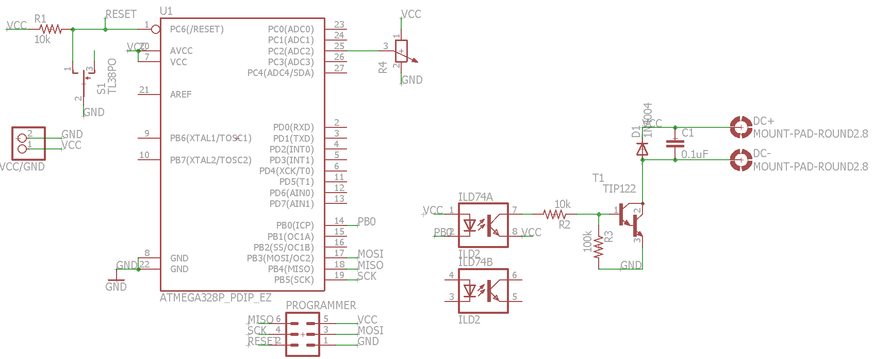

TASK 2:

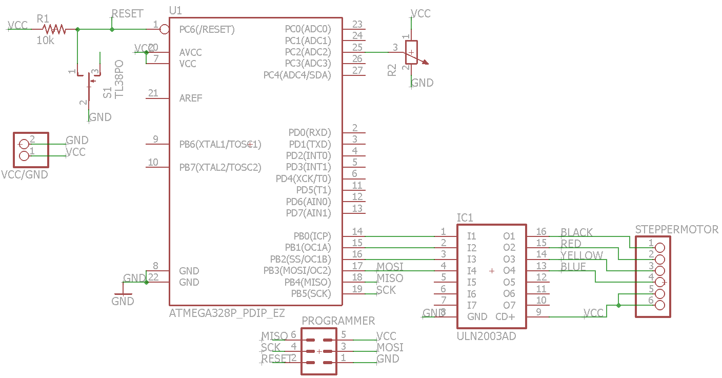

TASK 3:

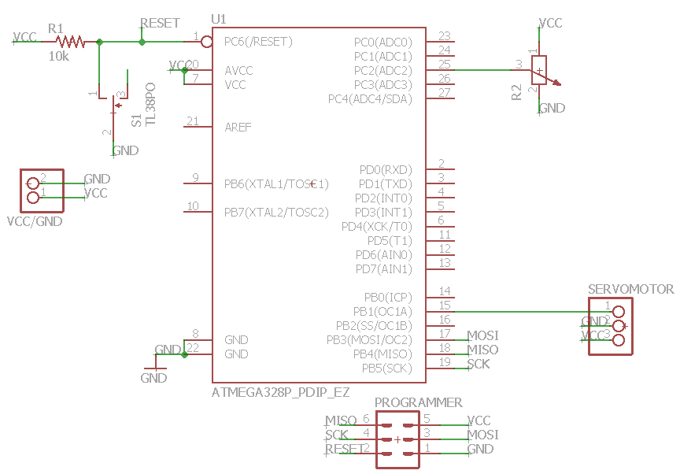

|  |  |  |  |
| --- | --- | --- | --- |
| 7. | SCREENSHOTS OF EACH TASK OUTPUT |  |  |

TASK 1:

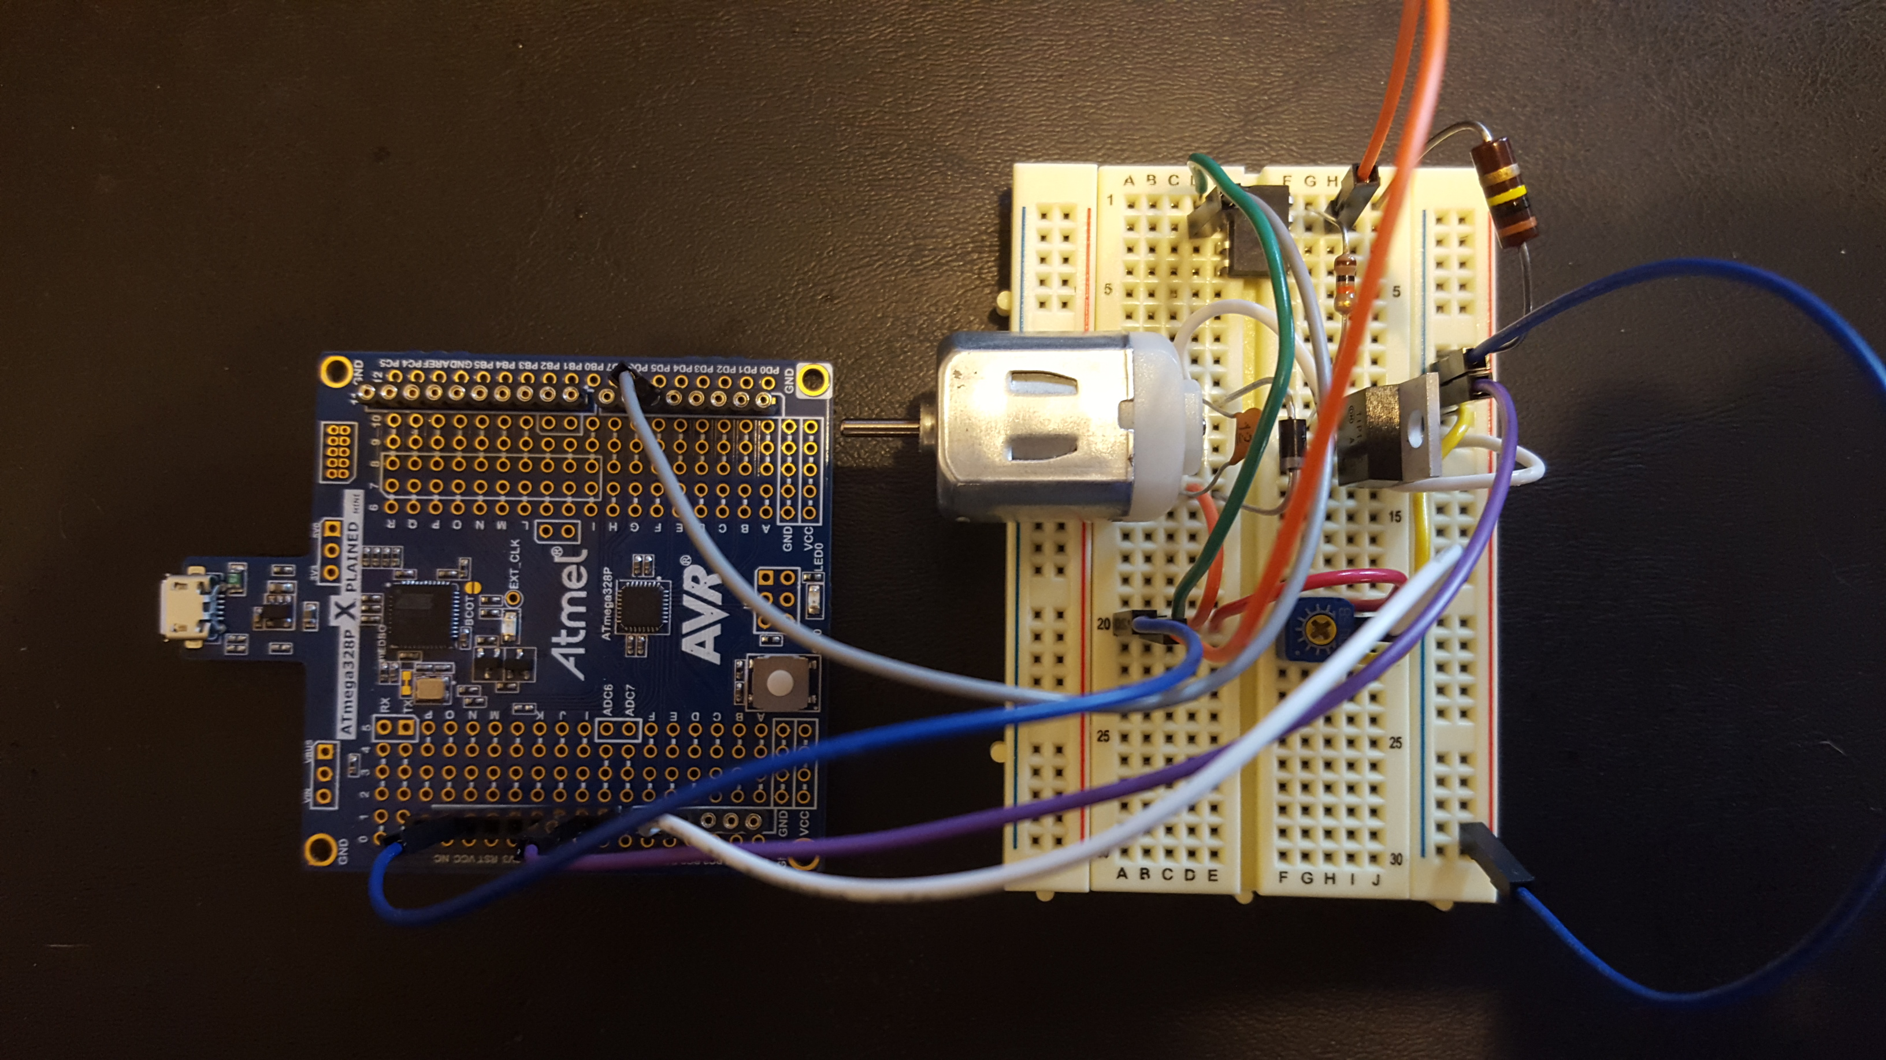

TASK 2:

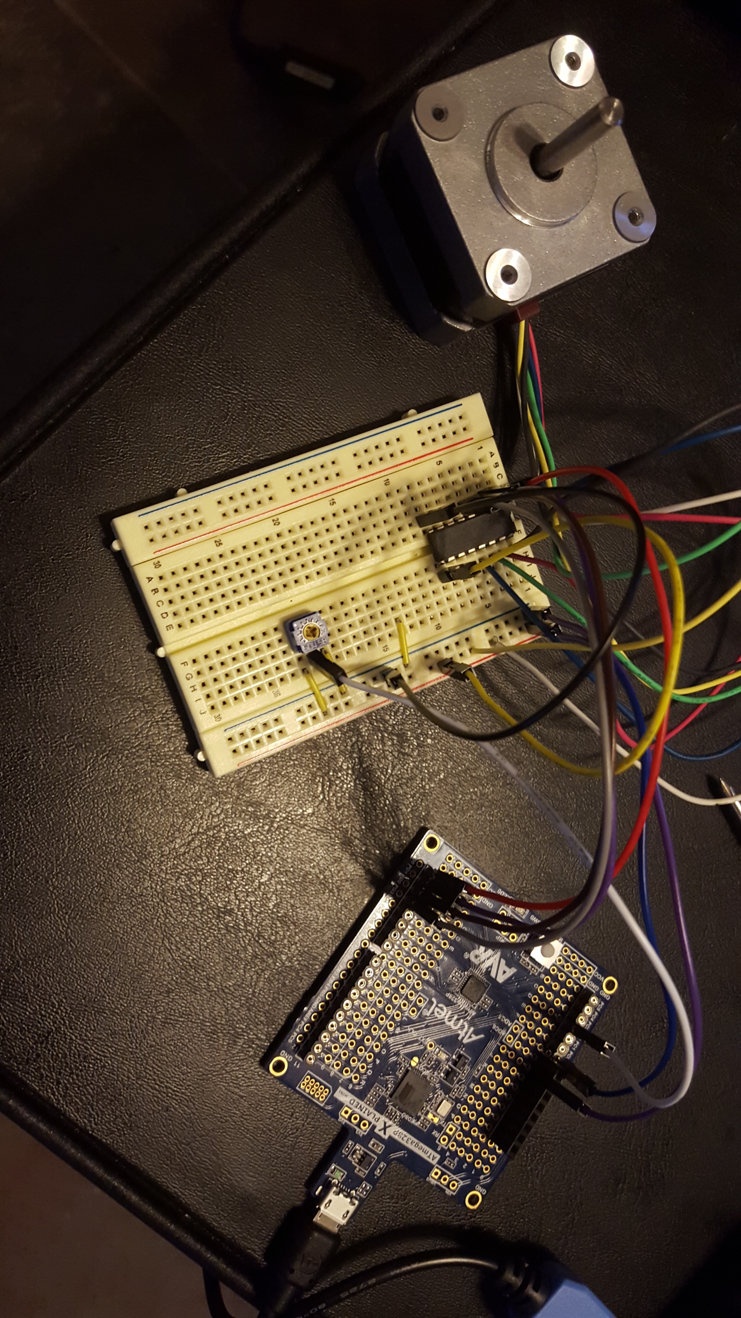

TASK 3:

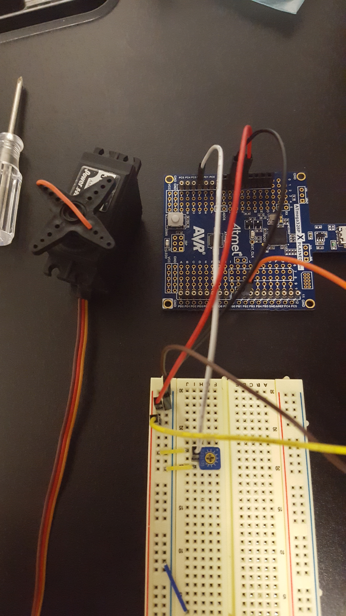

|  |  |  |  |
| --- | --- | --- | --- |
| 8. | SCREENSHOT OF EACH DEMO |  |  |

TASK 1:

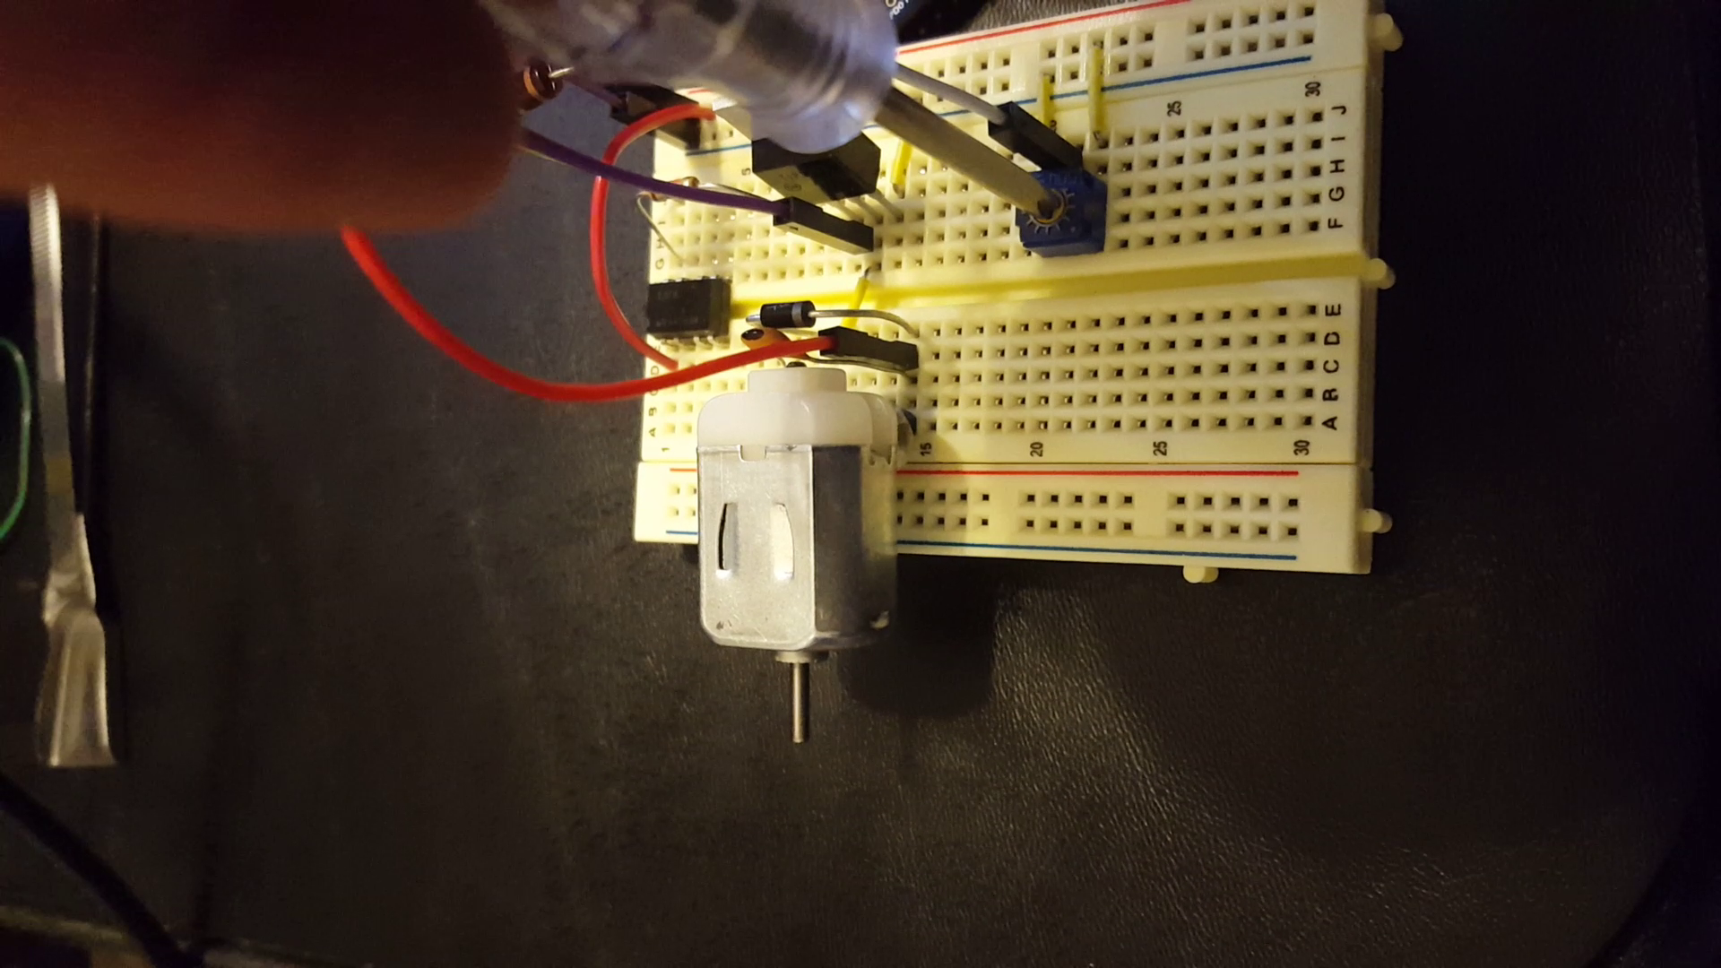

TASK 2:

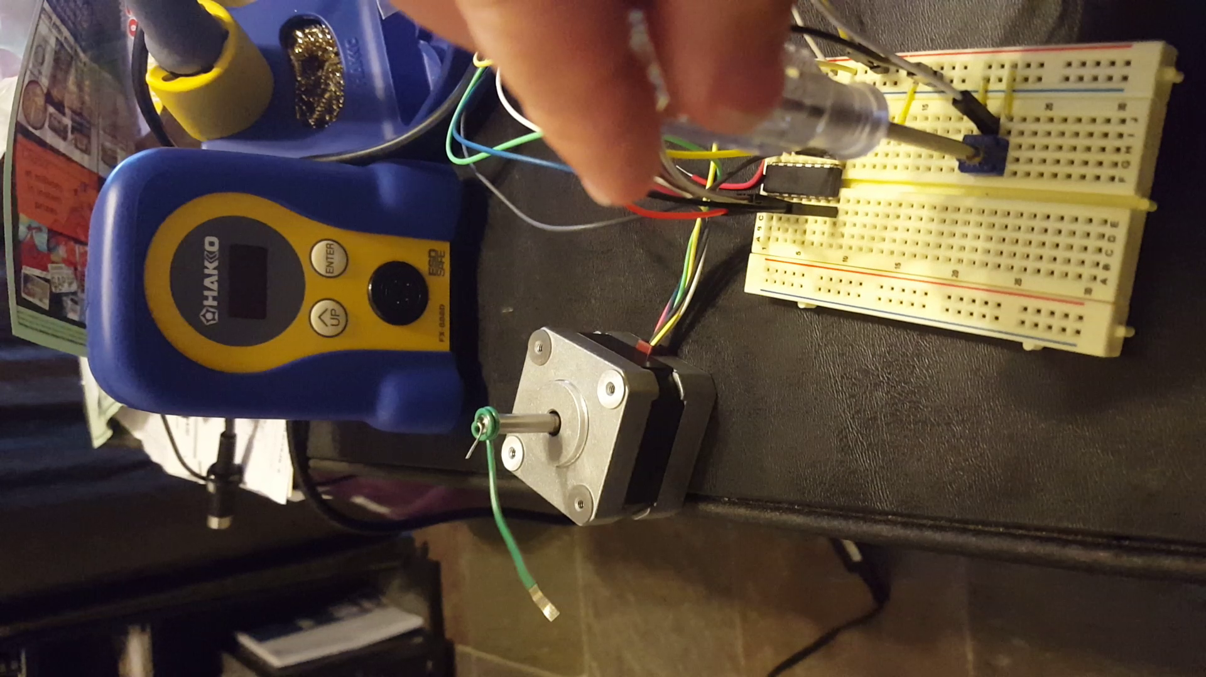

TASK 3:

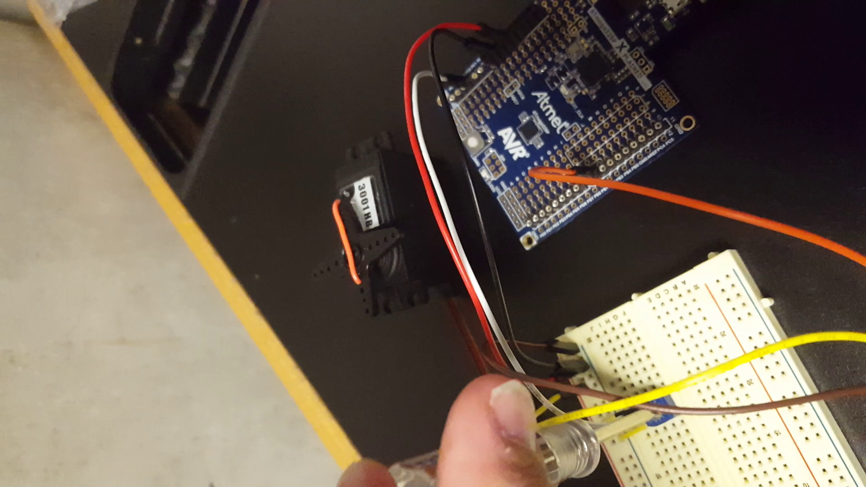

|  |  |  |  |
| --- | --- | --- | --- |
| 9. | VIDEO LINKS OF EACH DEMO |  |  |
| See videos_DA5.txt file | | | |
| 10. | GOOGLECODE LINK OF THE DA |  |  |
| https://github.com/Wellsa15/wellsa_unlv | | | |

**Student Academic Misconduct Policy**

<http://studentconduct.unlv.edu/misconduct/policy.html>

“This assignment submission is my own, original work”.

Andrew Wells